BIFS 614 – Data Structures and Algorithms
Week 7 Lecture – Introduction to Linux & The Command Line

By now you’ve seen that many of the algorithms we use in bioinformatics are not your “standard” sort of application with a graphical user interface – in fact, most hardcore bioinformatics gets done on the command line – and that typically means a linux (or MacOS, which is linux under the hood) operating system. This week you will become familiar with linux and some of the basics of working via the command line.

To begin with you will need access to a computer running linux. There are many flavors of linux, and while they have differences in the way that they are maintained and updated, the basics of the command line are common to all of them. For purposes of this class we will be using Ubuntu, which is a “Debian” based linux that is one of the easiest to install and use.

Your Personal Linux Machine

Don’t panic – you do not need a new computer, or even to replace the operating system on your computer, to install Ubuntu. You can, if you wish, install Ubuntu “next to” your Windows operating system (creating a dual-boot system), but that is completely optional and in fact I would recommend against it unless you are very comfortable tweaking your computer. Instead, we will use a hosted linux solution provided by UMGC through our Lab Broker.

To access your personal hosted Linux machine, you will need to go to the COURSE RESOURCES section of the classroom and look for "Lab Broker":

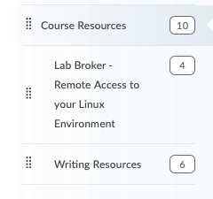

When you click on the Lab Broker section in Course Resources, you'll see this on your screen:

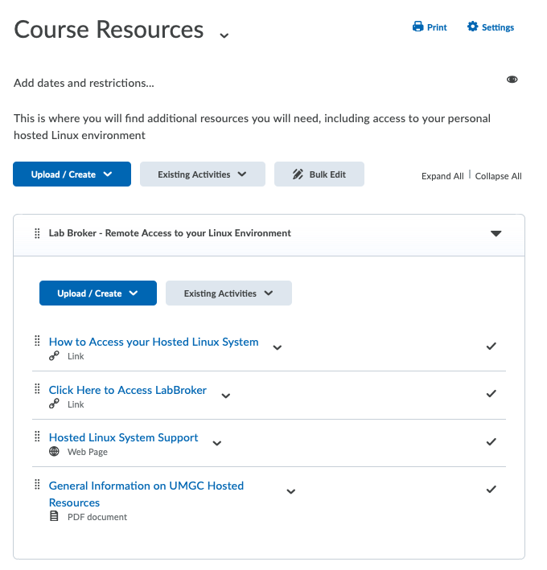

You can click on the "Click Here to Access LabBroker" link, although you might want to first click on the "How to Access your Hosted Linux System" link and watch the video first if you have never used Lab Broker before. A login and password combination will be provided to you separately.

NOTE: Linux does not show any activity when entering a password (e.g., it won’t show you an asterisk for every character you enter). So if you start typing your password and don’t see anything, nothing is broken – just continue and hit RETURN!

FIRST STEPS: UPDATING LINUX

Once you have access to your Hosted Linux, you'll probably want to make sure that all of the software on it is up to date. Ubuntu has a nice built-in update system called “apt”. It’s good to make sure that you have the latest versions of all of the components of linux, so the first thing we are going to do is learn how to use apt a bit. This is also going to be useful in the next step, where you will learn how to install some software (which is referred to as installing packages).

Log in using the supplied. You will be taken to the Ubuntu desktop (note that this may be different if you are using the UMGC hosted Linux – you will not have any icons or a visible dock):

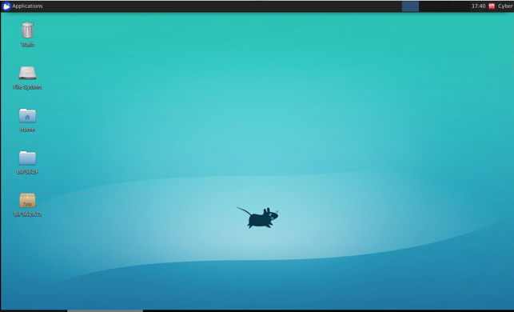
Figure 1: Ubuntu 18 Desktop
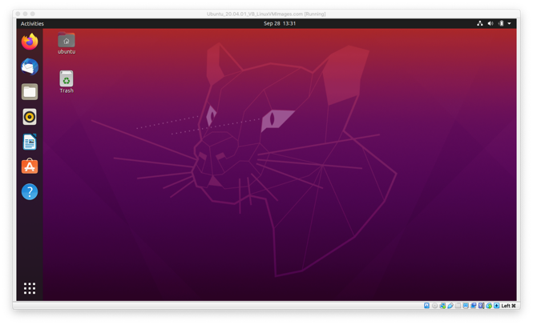
Figure 2: Ubuntu 20 Desktop

If you are using the UMGC Hosted Linux you will see this:



Ubuntu gives you a nice Desktop, just like Windows or Mac. But we want to work on the command line! Notice that there is a dock at the bottom – the terminal application is the second from the left. Go ahead and click that.
NOTE: if you go “full screen” on the desktop and lose the dock you can get it back by clicking the ACTIVITIES button in the top left).

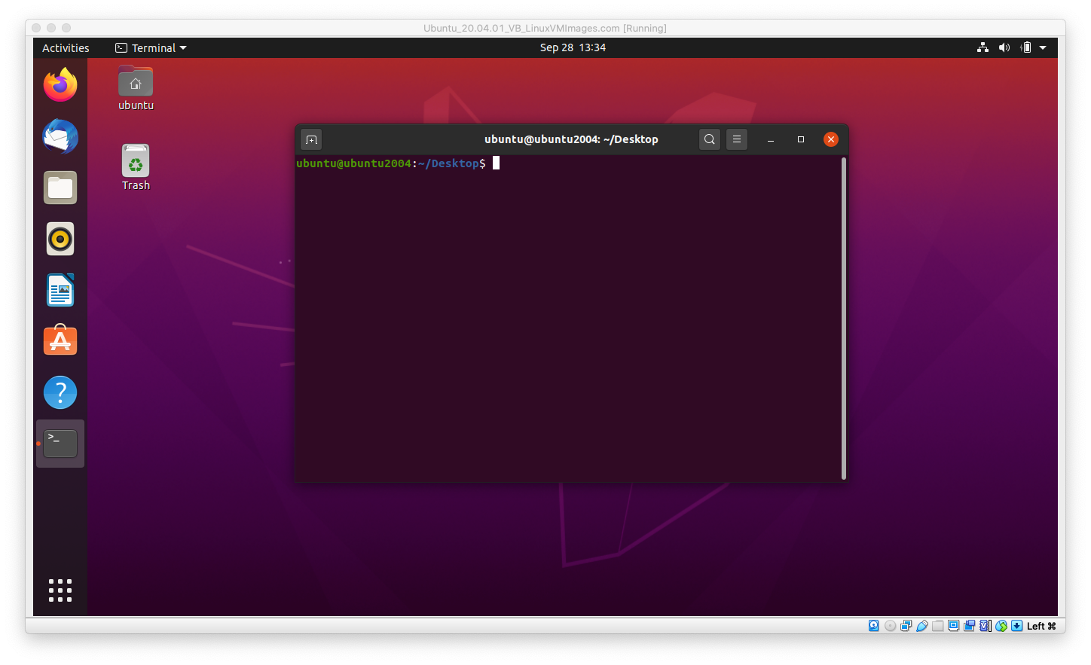
Notice that not only did a terminal window open, but there is an icon for the terminal in the dock on the left. You can right-click on that icon to make it stay in the dock permanently so that you can access the terminal without the right-click next time.

Now (left)click inside the terminal to make it the active window and type:

sudo apt update

and press return. The sudo command tells Ubuntu that you want to run the apt update command with administrative privileges; in most systems you’d have to enter your password after that, but in this particular install you are already the admin. Ubuntu looks for updates and if there are any it tells you. You can install the updates by typing:

sudo apt upgrade

and pressing return. Ubuntu will list the updates and then ask you if you want to proceed; enter ‘y’ to continue.

NOTE: linux lets you string commands together commands using “&&”; for example, you could have simply typed:

sudo apt update && sudo apt upgrade -y

This will execute first the apt update, then the apt upgrade with a default answer of “y”.

The update process may take some time – go grab some coffee, or if you’re really gung-ho, go to Amazon or your library (or a used bookstore) and get a copy of “Linux in a nutshell” – it’s a great command reference for linux and you can usually get it used for about $5. You should also be aware that the screen saver may kick in and blank the Ubuntu screen – don’t worry, just click in the window to continue.

Now you’ve updated linux – let’s do some more interesting things.

INSTALLING PACKAGES

Earlier in this course we learned about some basic bioinformatics packages like samtools and minimap2. While you won’t be able to use minimap2 to map sequences against the human genome with this particular system (you would need a linux machine with at least 32Gb of RAM to do that), you can map smaller datasets. Since you’ll need that for this week’s homework, let’s go ahead and install samtools and minimap2. In your terminal window type:

sudo apt install samtools

and press return. Enter “y” when asked, and Ubuntu will go ahead and install samtools. After the install, go ahead and type:

samtools

into the window and press return – notice that if you execute a command without any of the additional information (e.g. the flags, file inputs, etc), linux will usually just give you a quick “help” file output.

Go ahead and install minimap2 the same way. Depending on the version of linux you are using, you may have to install minimap2 in a different way:

curl -L https://github.com/lh3/minimap2/releases/download/v2.20/minimap2-2.20_x64-linux.tar.bz2 | tar jxf -

sudo cp minimap2-2.20_x64-linux/{minimap2,k8,paftools.js} /usr/bin

You can (and should) read more about minimap2 on it's github page at https://github.com/lh3/minimap2.

NOTE: while it seems easy and intuitive to install and run applications in linux, it isn’t always – you have to know the exact name that it is expecting. For example, if you wanted to install Mr. Bayes, the Bayesian phylogenetic reconstruction software, you would type sudo apt install mrbayes to install it, but at the command line you would simply type mb and return to launch it.

BASIC LINUX NAVIGATION: pwd, cd, ls, mkdir, mv, rm, which, df, ln -s, and alias

Navigating directories and files is a little different from the command line. Let’s start by seeing where exactly we are in the terminal by typing the following command and pressing return:

pwd

While you might guess that this is a password command, pwd actually stands for print working directory. This will output the directory that you are currently in, which is /home/StudentFirst (your home directory).

The command for changing directories is cd, but there are many ways to use cd. For example, if you type:

cd ..

followed by the pwd command, you will see that you are now in the /home directory. So using cd to change directories followed by “..” moves you up one level in the hierarchical directory structure. You can’t do any work here since you don’t have permissions, so go ahead and type cd StudentFirst and press return to go back home. You could also just type this (from any directory) to jump immediately home:

cd ~

Now that you are in your home directory (recall that you logged in as user ubuntu), let’s see what files you have in there. Use this command:

ls

As you can see, ls is the list command. Again there are variations in what you can do with this command. For example, try ls -al instead and you will list everything in the directory, including invisible files and directories (they start with a “.”), as well as their permissions, ownership, creation date, etc.

Now let’s create a new directory that you can work in. The mkdir command will create a directory:

mkdir homework4

Notice how I combined homework and 4 – that’s because linux does not like spaces in words – in fact, it would interpret mkdir homework 4 as a request to create two separate directories, one called “homework” and another called “4”. To make things neater we could have called the directory “homework_4” – let’s use another command, mv, to do that.

mv homework4 homework_4

The mv command is the move command. It is really a renaming command, but move makes sense too. Notice that we passed the mv command two inputs – one is the existing named item, and the second is the name we are moving it too. Many linux commands work this way – and additionally you can add flags and other controls on the command line….more about that later.

Now let’s remove our new folder – essentially deleting it. In linux the rm command removes a file, whereas rmdir removes a directory. Since homework_4 is a directory let’s do this:

rmdir homework_4

Alternately, you could use a flag and the rm command:

rm -r homework_4

The -r flag tells rm to act recursively, removing the item and anything contained inside of it. Most linux commands support the use of flags and other ways of controlling their function.

There’s another trick that you should be ready for now. While your cursor is in the terminal, press the “up” arrow on your keyboard. You’ll see that the last command you entered is displayed, ready to be run again. You can edit this command, or you can keep pressing the “up” arrow and go back through the entire history of the commands you’ve entered this session. This is a nice way to repeat commands with minor changes, or to see what you’ve been doing.

Now let’s imagine we are about to start writing a large python program. First let’s make sure we have python3 installed. We could just try executing python, but instead let’s use the which command:

which python3

After typing the above (you should know by now to press return at the end of commands) you should see this line:

/usr/bin/python3

The which command asks linux to tell us which program we will run if we give it a program name. You may ask why this is useful, and it’s a fair question. The answer is that linux (like most other operating systems) can end up having lots of different applications installed, and not always where you expect them to be – so the command which python3 lets us know that (a) python3 is in fact installed, and (b) we will be using the python3 that has it’s executable stored in /usr/bin/.

Now let’s make sure we have enough free disk space to write our program. We can do that using the df command:

df -h

Notice that we used another flag – in this case, the -h flag, which tells our application df (or disk free space) to report the results in human-readable format. There’s a lot of information here, and we really only care about the entry at /dev/mapper/vgubuntu-root, which is the “hard drive” that we are using for ubuntu. If you look at the column marked “Avail” you will see that in my system I have 86Gb free out of 97Gb:

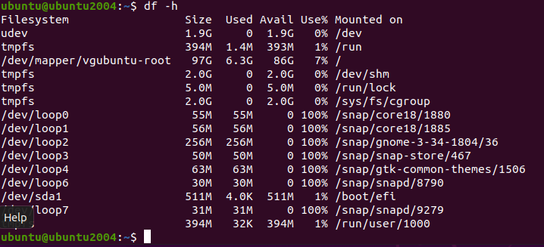

Let’s pull a few more tricks out to make this easier to read – try entering this command:

df -h | grep “/dev/mapper/”

This gives us just the single line from the above:

How did this work? We took our same command, df -h, and used the “|” character (the straight up-and-down line, which on my keyboard that is the shift version of “\”) to “pipe” the output of df to grep. Grep is a search function that we’ll go into later, but essentially we searched the output of df -h looking specifically for a line that included “/dev/mapper/” – and grep returned the single line for us.

You can use “|” to pipe the output of any command to the input of any other command. Very useful!

If we wanted to now start using python to write our program, we would type the following command:

python3

This would bring up the python command line interface:

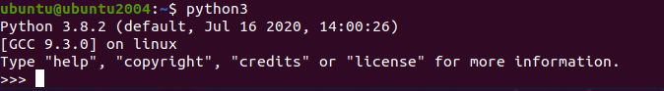

While this is fine, I know that I don’t always remember to put the “3” at the end of “python” – I’d rather just be able to run python by typing “python”. Luckily we can customize linux to enable us to do that – and more.

To quit python, enter the following command:

exit()

Now check your current directory using the pwd command. Notice that you are still in your “home” directory. Just in case you have explored the filesystem a bit, here’s a command that will instantly return you to your home directory, regardless of where you are:

cd ~

We used the change directory, or cd command, just like before – but this time we told it we wanted to go to the “~” location. That tilde tells cd to take you home! You could just as easily have typed the whole path, like this:

cd /home/StudentFirst

Recall that “StudentFirst” is the name of the user we logged in as. On my personal linux machine, for example, my home directory is actually “/home/wolfgang/”.

Now that we know we are in our home directory, let’s take a look at all of the contents again using this command:

ls -al

Notice that there is a hidden file called “.bashrc” – that’s where linux stores configuration data for the bash terminal. Let’s append a line to the bottom of this file – without using an editor (we’ll learn how to use the terminal to edit files later):

echo alias python=’python3’ >> .bashrc

There’s a lot going on – let’s break this down.

echo

This command repeats back whatever you type after it, so echo alias python=’python3’ simply makes the terminal print out “alias python=’python3’. You may have noticed that nothing was printed out, though – that’s because of these characters:

>>

This pattern of characters is known as the “append” command. It basically redirects the terminal output and appends it to whatever file you list after it. So that’s why the terminal didn’t print anything from the echo command; it was redirected and appended to the file .bashrc

So what does this do? It adds a command at the bottom of your bash configuration file that tells it that whenever you type the word python you really mean python3. So now, instead of having to type python3, you can simply type python to launch the python3 application.

Let’s see if it worked. Exit the terminal by clicking on the button at the top right of the terminal window. Now relaunch it (with a right-click on the desktop or using the toolbar, if you added it) – this reloads the .bashrc file, so your alias command should now be active. Enter the command:

python

And if you see python3 launch, it worked!

There’s one last basic linux command we’re going to learn this week, and that’s the autocomplete function. Make sure you are in your home directory, then type the following (but do NOT press RETURN):

cd De

Now press the TAB button. Linux will autocomplete to the only directory you have that starts with “De”, which is “Desktop”. But before you press RETURN, let’s change the command. Delete the last “e” so that your command looks like this (again do not press RETURN):

cd D

If you press TAB once, nothing happens – that’s because you have three different directories that start with “D”: Desktop, Documents, and Downloads. Press TAB twice, though, and you’ll see a list of exactly those three folders.

Using TAB as an autocomplete works inside of bash (the terminal), and you can use it for filenames, folder names, or for commands. For example if you type py and hit tab twice, you’ll see all of the commands that being with py.

Go ahead and exit your hosted Linux machine (unless you want to play around some more on your own). Next week we will learn how to do a variety of file viewing and manipulation in linux – essential stuff for a bioinformaticist.

